USB-TAU D Description

General Description
USB-TAU D is a Universal Serial Bus (USB) Terminal Adapter Unit designed for connection to the Ericsson exchanges ASB 501 and ASB 150 or equivalent and allows voice transmission and signal channel access over the two wire digital extension line 2B+D. It is intended for connection of OWS, Application link, PSC or equivalent together with a digital telephone, type Dialog 42xx or equivalent.
Signal channel access is made possible by adoption of the USB 2.0 interface, which is connected to a port on the USB-TAU D to the exchange signal channel data format. The format allows transmission of asynchronous data and is seen as serial port (RS232 compatible) by DTE. USB-TAU D is also USB 1.1 backward compatible.
The signals are received and transmitted using a Ericsson’s proprietary layered protocol.
Voice transmission is enabled over the digital extension line to which a digital telephone is connected to USB-TAU D. The telephone and USB-TAU D are power fed from the exchange. The USB-TAU D is built up on a proprietary circuit board based on a microprocessor, burst signaling circuits, interface circuits and voltage controller block. The board is housed in a plastic box.
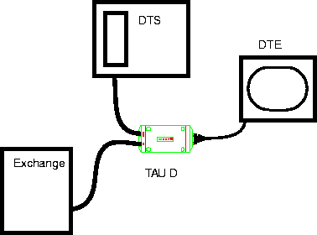
PC
USB 2.0
USB-TAU D
DTE
DTS
Exchange

Figure: 1. Example of USB-TAU D connection with DTS.

Terminology
DTS | Digital Telephone Set
DTE | Data Terminal Equipment
DASL | Digital Adapter for Subscriber Loops
AMI | Alternate Mark Inversion
FNC | FuNCtion code
PBA | Printed Board Assembly
PSC | Personal Screen Call
VCP | Virtual COM Port
USB | Universal Serial Bus

Mechanical structure

Main Parts
The device consists of two identical ABS plastic parts that are snapped together by means of four hooks. The PBA is held in place by three screws. Three connectors are mounted on the PBA for connection of Exchange, Telephone and Terminal.
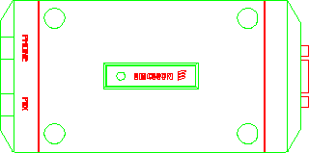
Phone (DTS)
PBX (Exchange)
DTE (PC)
Figure 3-1. Top View
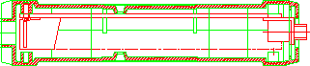
Figure 3-2. Side View
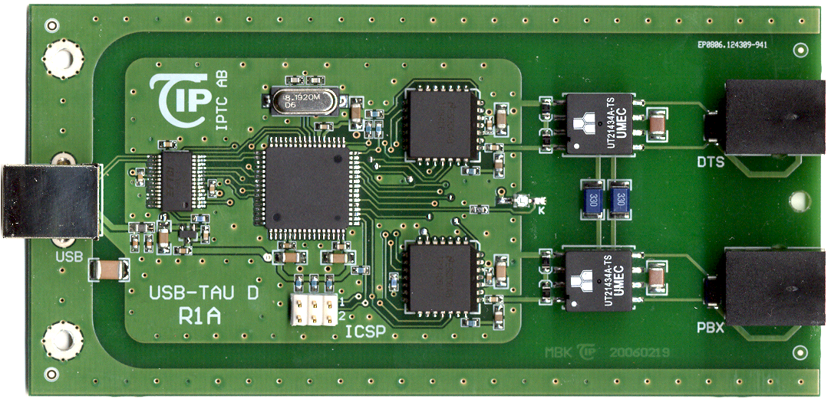
Figure 3-3. Printed Board Assembly View

Connectors

Data Terminal Equipment
The connector is a USB Type B female. The USB-TAU D supports USB 2.0 full-speed interface to DTE.
PIN NR. | PIN DISPOSITION | 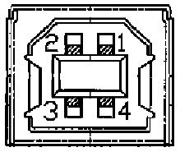  DESCRIPTION
1 | VBUS | +5V (4.75-5.25V)
2 | D- | Data (-)
3 | D+ | Data (+)
4 | GND | Ground
A shielded USB cable shall be used to connect the USB-TAU D and the DTE. The maximum cable length between DTE and USB-TAU D is 5 meters (16.5 feet).
Longer runs than 5 m can be achieved thru the use of powered USB hubs. Up to 5 USB hubs can be used in cascade allowing absolute maximum distance of 30 meters (100 feet) between DTE and USB-TAU D.

Line to the Exchange
The connector is a six pole RJ12 connector marked exchange and is located in the rear of the unit.
PIN NR. | 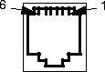  PIN DISPOSITION
1 | Tape recorder
2 | Busy Signal/ Extra bell +
3 | Line
4 | Line
5 | Busy Signal/ Extra bell -
6 | Tape recorder
Market adaptations are made by strapping the cable to a different configuration.
The tape recorder and Busy Signal/ Extra bell pins signals are being transferred from the telephone instrument to the exchange interface and are only active if the respective telephone instrument supports the facility.

Telephone Line
The connector is a six pole RJ12 connector marked PHONE which is located in the rear of the unit.
PIN NR. | 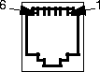  PIN DISPOSITION
1 | Tape recorder
2 | Busy Signal/ Extra bell +
3 | Line
4 | Line
5 | Busy Signal/ Extra bell -
6 | Tape recorder
Market adaptations are made by strapping the cable to a different configuration.
The tape recorder and door indicator pins signals are being transferred from the telephone instrument to the exchange interface and are only active if the respective telephone instrument supports the facility.

Functional Description
PBX
DTS
Line
Conn.
Transmission
Interface

Microcontroller
Oscillator
USB Interface
Power
Supply
DTE (PC)
Transmission
Interface
Line
Conn.
60 mA from USB
<500 uA in stand-by
High voltage barrier
+5V
48V
Figure 4-1. Block Diagram of the R1A

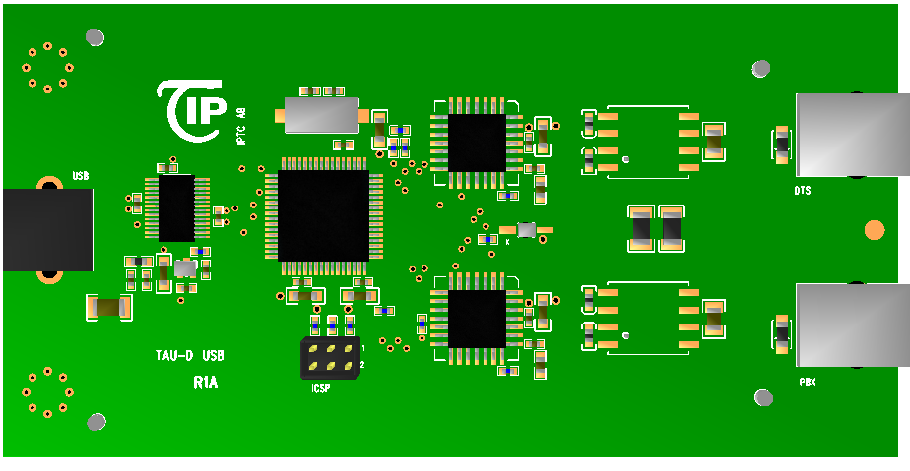
PBX
DTS
High voltage barrier
Microcontroller
Transmission If.
USB If.
Line Conn.
+5V PS
XTAL
In-Circuit Serial Programming
USB
AVR
DASL
DASL
USB
Figure 4-2. Printed Board Assembly Layout

Control Section
The control section consists of a micro controller, oscillator and a watch dog circuit.

Microprocessor
A micro controller with internal Flash ROM (64KiB – 256Kib), EEPROM (2KiB), RAM (4KiB-8KiB), and built-in two USARTs is used. Interface towards USB is achieved using specialized USB FIFO circuit.

Oscillator
An 8.192 MHz crystal generates the Clock used for the micro controller. The frequency is divided to 2.048 MHz to the slave DASL.
The slave DASL provides the regenerated exchange system clock for the master DASL.

Watch Dog Circuit
The watch dog circuit gives a well defined reset pulse when power is supplied to the USB-TAU D. The watch dog circuit also has to receive trigger pulses from the address decoding logic to reset the watch dog periodically. If there is no trigger pulse the USB-TAU D will be reset and restarted.

Light Emitting Diode, LED
The Light Emitting Diode is PWM (Pulse Width Modulation) controlled directly from the microprocessor under the firmware program supervision.

OVP Over-Voltage Protection
The circuits are primarily protected by a TVS across both exchange and phone line. The circuits power ground is isolated from the phone and exchange lines by line transformers 2kV hi-pot barrier.

USB Interface
The USB-TAU D supports USB 2.0 full-speed interface to DTE. USB interface provides end point seen as serial port when using appropriate device driver on DTE.

Voltage Controller
The USB-TAU D is powered from USB, and not from exchange.
System power supply is USB compliant and has soft-start that limits start-up to be at least 400us thus protecting USB hub from power current surge. Maximum current drawing from USB is 60 mA (typically 55 mA).

Line Circuit
The interface towards the digital extension lines are two DASL-circuits. One of them is placed towards the exchange line card and operates in slave mode, the other is placed towards the telephone instrument and operates in master mode.
The line interface includes line transformers and line terminations. Power feeding from Exchange is forwarded to DTS.
The digital transmission method used is burst signaling which means that a line circuit that operates in master mode transmits a burst of 37 bits towards the line every 250:th microsecond. The slave device receives the burst, waits the specified guard time and transmits its own burst towards the line.
Of the bursts 37 bits one is a synchronization bit, the first bit, 8+8 bits are reserved for channel B1, 8+8 bits are reserved for channel B2 and 2+2 bits are reserved for channel D. Within the burst the bit speed is 384 kbit/s. The signalling capacity is 144 kbit/s.
The line code which is used is the so called AMI-code, Alternate Mark Inversion. In this code "zeroes" give no pulse while every other "one" causes a positive pulse and every other gives a negative pulse.
When bursts are exchanged every 250:th microsecond an equalization is needed in the DASL circuit before it can send or receive user data on the secondary PCM-channel since the PCM-channel timing relies on bursts of eight bits in a time slot exchanged every 125:th microsecond.

Synchronization

Synchronization between DASL Master and Slave
The first bit in the burst is always a "one". The rest of the burst is scrambled in a shift register with the polynomial
1 + x⁵ + x⁹. Besides the first bit in a burst the bits are scrambled in the successive bursts like a continuous pulse train. This procedure is used to synchronize the line circuits (master) and slave: "Ones" are scrambled as earlier mentioned and are sent in bursts by the master. After a maximum of 20 ms a burst of scrambled "ones" are sent from the slave. When the master and slave have detected four correct bursts respectively in a row, the synchronization is completed.
The maximum time for the synchronization is 100 ms.
The synchronization is considered lost when four faulty bursts in a row are detected. Examples of faulty bursts are: incorrect AMI-code, faulty polarity, incorrect start bit and the burst is off time.
If this is the case the receiver line circuit tries to resynchronize according to the procedure above.

Signaling

Signaling In General
Over the D-channel, 16 kbits/s, format signals with checksum are exchanged between the line card and connected equipment. A master-slave configuration is employed when a master polls a slave device to see if it has any signal to send.

Signal Protocol for D-channel
Signaling on the so called D-channel utilizes the line circuit in conjunction with two USART's (Universal Synchronous Asynchronous Receiver Transmitter). Exchange of signals between the line card in the exchange and its connected equipment is done as follows.
The line card polls individual after individual in a cyclical scheme. If the line card has something to send to an individual the signal is sent and an acknowledgement expected. When the acknowledgement is received the individual is polled to see if it has any signal to send. The individual is expected to either send a signal or a negative poll answer. This procedure is repeated cyclically per individual activated on the line card.
The USB-TAU D is master to its connected telephone instrument and thus shows to the telephone the same protocol as the line card does.

Signaling Format for D-channel
Signals exchanged on the D-channel consist of blocks built up of 4-47 signal octets of 8 bits each.
7 | 6 | 5 | 4 | 3 | 2 | 1 | 0
NBYTES |  |  |  |  |  |  |  | Octet 1
OPC |  |  | P | SN |  |  | I | Octet 2
FNC |  |  |  |  |  |  |  | Octet 3
... |  |  |  |  |  |  |  | Octet 4
CHECKSUM |  |  |  |  |  |  |  | Octet n

Signal Words
Octet exchange on the D-channel is made by using start and stop. The signal octet of 8 bits is preceded by a start bit and followed by a stop bit before the next signal word is allowed. Thus a signal word consists of 10 bits

The First Signal Octet, NBYTES
The first signal octet NBYTES tells how many signal octets the signal consists of and takes the values in the interval 4 to 47.

The Second Signal Octet
The second signal octet consists of three parts:
OPC | The operation code 3 bits states the signal priority i.e. A-level or B-level signals.
SN | The sequence number 3 bits keeps count of how many signals that have been sent in a certain direction. SN counts modulo 8. A signal has the same sequence number when due to no acknowledgement received retransmission occurs.
I | The channel selection bit determines if the signal concerns equipment connected to the B1-,I=0 or B2-, I=1 channels respectively.

The Third Signal Octet
The third signal octet starts the signal message field and contains the function code, FNC.
The remaining part of the message field contains parameters belonging to the function code and if required, more function codes with appurtenant parameters.

The Check Sum, CS
The check sum consists of the 8 least significant bits of the sum of the value of the incoming signal octets minus one.

Data Format on the USB Interface
A USB system has an asymmetric design, consisting of a host controller and multiple daisy-chained devices. Additional USB hubs may be included in the chain, allowing branching into a tree structure, subject to a limit of 5 levels of branching per controller. Not more than 127 devices, including the bus devices, may be connected to a single host controller. Modern computers often have several host controllers, allowing a very large number of USB devices to be connected. USB cables do not need to be terminated.
USB was designed to allow peripherals to be connected without the need to plug expansion cards into the computer's ISA, EISA, or PCI bus, and to improve plug-and-play capabilities by allowing devices to be hot-swapped (connected or disconnected without powering down or rebooting the computer). When a device is first connected, the host enumerates and recognizes it, and loads the device driver it needs.

Operating System Device Driver Support
USB device driver for Virtual COM Port (VCP) exists for the following operating systems:
- Windows 98, 98SE, ME, 2000, Server 2003, XP
- Windows Vista / Longhorn
- Windows XP 64-bit
- Windows XP Embedded.
- Windows CE.NET 4.2 & 5.0
- MAC OS 8 / 9, OS-X
- Linux 2.4 and greater
Device driver is built-in in Windows XP, and is available on the other MS operating systems using “Windows Update” option when USB TAU D is first time connected to the PC.

Layer 1 Description
USB works in full-speed mode allowing maximum throughput of 12 Mbps. USB Serial Port speed and settings configuration is automatically adjusted and can range from 1200 to 2.4 Mbps:
Data Speed: | 1.2 kbit/s – 2.4 Mbit/s
Format: | Asynchronous
Data bits: | 8
Parity: | None
Stop bits: | 1

Layer 2 Description
The general format for signals sent over the physical interface is the same for both signals to or from an end point device. The general frame format is as follows.
7 | 6 | 5 | 4 | 3 | 2 | 1 | 0
FRMFLG1 |  |  |  |  |  |  |  | Octet 0
FRMFLG2 |  |  |  |  |  |  |  | Octet 1
FRMBC |  |  |  |  |  |  |  | Octet 2
FRMCTL |  |  |  |  |  |  |  | Octet 3
FRMADR |  |  |  |  |  |  |  | Octet 4
FRMDATA1 |  |  |  |  |  |  |  | Octet 5
FRMDATAn |  |  |  |  |  |  |  | Octet n
FRMCS |  |  |  |  |  |  |  | Octet n+1

FRMFLG Frame Flag
Every frame starts with two flags. The flags are fixed to 15 hexadecimal.

FRMBC Frame Octet Count
The frame octet count is the number of octets in the frame, excluding the two opening flags. The frame octet count is a number in the interval 4 to 47. FRMBC in enhanced mode can be 4 – 311 bytes long.

FRMCTRL Frame Control
Each frame contains a frame control octet which determines the frame type, and also contains a frame sequence number.
FRMSN: | The sequence number 4 bits keeps count of how many signals that have been sent in a certain direction. FRMSN counts modulo 16.
FRMTYPE: | The frame type is contained in the lower four bits of the frame control octet.

FRMADR Frame Address
The Frame Address octet is used for identification of the frame source or destination for proper routing of the frame.

FRMDATA Frame Data
The FRMDATA is only used by some frame types and the length could vary from 1 octet to 47 octets, or 1 to 305 octets in enhanced mode.

FRMCS Frame Checksum
The frame check sum consists of the 8 least significant bits of the sum of the value of the incoming frame octets, not including the Frame Flags, minus one.

Interface towards the Exchange
USB-TAU D is connected to the exchange over a two wire digital extension line. The extension line is divided into three channels, two 64 kbit/s channels so called B-channels, B1 and B2, and also a 16 kbit/s channel called a D-channel.
Burst transmission and AMI-code are used.
Channel B1 is primarily used by the connected telephone to transmit PCM-coded speech through the USB-TAU D.
Channel B2 is transparent in the USB-TAU D.
Channel D is utilized to exchange signals between the exchange software and the telephone when connected, and between the exchange software and the connected data equipment. USB-TAU D transits the signals to and from the telephone. Channel D is only used to handle signal information, not for user data.
The length of the extension line that the USB-TAU D can handle is determined by the transmission delay and current consumption on the line i.e. the type of cable used.

Interface towards the Digital Telephone Instrument
The telephone instrument is connected to the USB-TAU D over a digital extension line. The extension line is divided into three channels, these channels are the same as for the extension line from the USB-TAU D towards the exchange.
Channel B1 is utilized by the connected telephone to transmit PCM-coded speech through the USB-TAU D to the exchange in full duplex.
Channel B2 is transparent.
Channel D is utilized to exchange signals between the exchange software and the telephone when connected, and between the data equipment and the telephone when connected.
USB-TAU D transfers signals to and from the telephone and shows the same interface as the line card concerning signaling and signal protocol.

Interface towards the Data Terminal Equipment
The interface towards the DTE consists of an USB 2.0 full-speed interface. The connector is a USB Type B.
A shielded cable shall be used to connect the USB-TAU D and the DTE.

Interface towards the User
The user interface consists of a LED and LED is located at top of the device. The LED indicates the present status of the USB-TAU D.
NORMAL OPERATING: | The LED is slowly blinking (1 Hz). (No errors detected)
ERROR 1: | The LED is blinking fast (3 Hz). (An error has been detected)
ERROR 2: | The LED Is ON. (Processor failure)
ERROR 3: | The LED is OFF. (Power or processor failure)

Technical Data

Power Feeding
The USB-TAU D is powered from the USB port, and not from exchange.
Maximum power consumption is 0.3 W and the circuits are drawing maximum 60 mA from the USB port.
In USB stand-by mode, power consumption is limited to 500 µA.

Electro Magnetic Compatibility
The USB-TAU D is a CISPR 22 Class B device by implementing a two layer PBA together with appropriate filtering of external connections.

References
The design of USB is standardized by the USB Implementers Forum (USB-IF), an industry standards body incorporating leading companies from the computer and electronics industries. Notable members have included Apple Computer, Hewlett-Packard, NEC, Microsoft, Intel, and Agere.
The USB specification is at version 2.0 (with revisions) as of February 2006. Hewlett-Packard, Intel, Lucent, Microsoft, NEC, and Philips jointly led the initiative to develop a higher data transfer rate than the 1.1 specification. The USB 2.0 specification was released in April 2000 and was standardized by the USB-IF at the end of 2001. Previous notable releases of the specification were 0.9, 1.0, and 1.1. Equipment conforming with any version of the standard will also work with devices designed to any of the previous specifications (backwards compatibility).

AMI=Alternate Mark Inversion.

